**Project Design Phase-II**

**Technology Stack (Architecture & Stack)**

|  |  |
| --- | --- |
| Date | 03 October 2022 |
| Team ID | PNT2022TMID26382 |
| Project Name | Project - Statistical Machine Learning Approaches to Liver Disease Prediction |
| Maximum Marks | 4 Marks |

**Technical Architecture:**

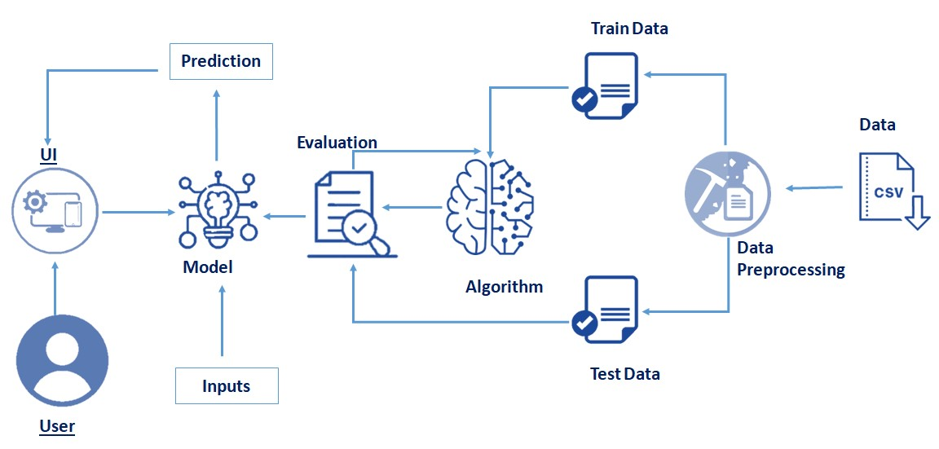

**Table-1 : Components & Technologies:**

|  |  |  |  |
| --- | --- | --- | --- |
| **S.No** | **Component** | **Description** | **Technology** |
| 1. | User Interface | A Web page which gets user input and send it to the backend for predicting the given input data | HTML, CSS, JavaScript |
| 2. | Predicting Model | Model which takes user input and predict whether the person have liver disease or not | Python, Numpy, Pandas, Scikit-learn |
| 3. | Web Server | A web server which serves static HTML user interface files and uses Predicting ML model to process output and send back to the client | Python, Flask |
| 4. | Machine Learning Model | The model used for classify whether the person have liver disease or not | Support Vector Machine Model |
| 5. | Cloud Deployment | The ML model is bind with web server and deployed in to the IBM cloud | IBM cloud, IBM Watson Studio |

**Table-2: Application Characteristics:**

|  |  |  |  |
| --- | --- | --- | --- |
| **S.No** | **Characteristics** | **Description** | **Technology** |
| 1. | Open-Source Frameworks | There are several opensource frameworks used for data preprocessing , data analysis , Model building , pickling and web servers | Numpy ,Pandas ,Seaborn ,Scikit-learn ,Pickle ,Flask |
| 2. | Security Implementations | Since no user data is stored in the server , There is no security issues in the application side | - |
| 3. | Scalable Architecture | It is a monolithic architecture and , if needed the model which is used to predict can be developed separately as a microservice | Microservices using Docker and Kubernetes |
| 4. | Availability | If the load increases a load balancer can be used to handle the huge request | Nginx Server, Load Balancer |
| 5. | Performance | The performance is still good and has no need the interference of external CDNs, It can able to handle adequate amount of network requests | - |